Contents
Report files (.RDLs) 1
The Reports folder 1
Opening a report (.RDL) 3
The Design pane 3
The Preview pane 5
The Report Data pane 7

Knowledge Article: not yet written
Additional guidance: How to manage reports on the HR Reporting servers
Additional guidance: How to create and amend reports in Visual Studio - pending
Additional guidance: How to manage parameters within Visual Studio - pending
Additional guidance: Formatting standards for .RDL files - pending
Additional guidance: Formatting standards for SQL queries - pending

Report files (.RDLs)

The Reports folder
Go to the Solution Explorer pane and expand the Reports folder. You will be presented with a list of the report files currently available to open within the solution.

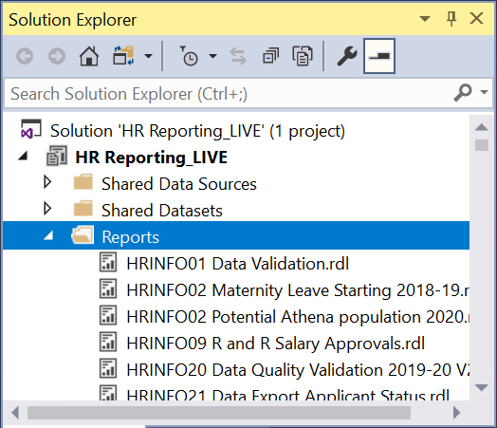

 | NB: This is not the total list of existing .RDL files within a solution. Visual Studio will only display a limited number of files in the Solution Explorer pane, but you can add existing .RDL files to the Solution Explorer pane by following the steps below.

If you want to view an existing .RDL file but do not see it displayed in the Solution Explorer, you can add it into the Solution Explorer by going to the Reports folder and right-clicking it. Select Add > Existing Item… (or type Shift + Alt + A):

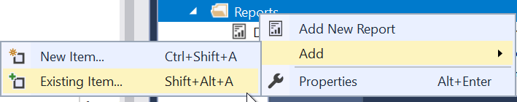

The solution folder on I:\OUIT\CoreHR Reports will open. This folder contains all the files which belong to the solution that you are currently working in:

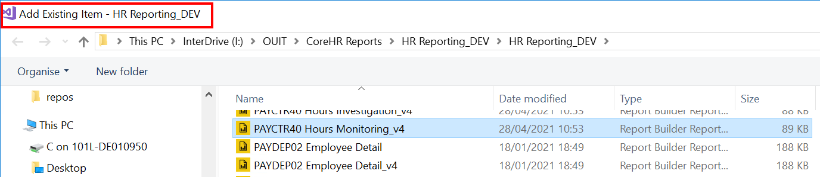

If you want to add an .RDL file from a different solution, navigate back to the main I:\OUIT\CoreHR Reports folder and select the solution file you want to open. You can see from the title bar and the file path here that you are selecting files from the DEV solution to add them to the QA solution:
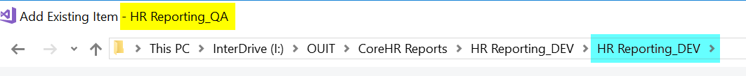

Scroll through the solution folder until you find the file you want to add to the Solution Explorer, then select it and click Add:

The file you have added will now appear at the bottom of the Reports list within the Solution Explorer:

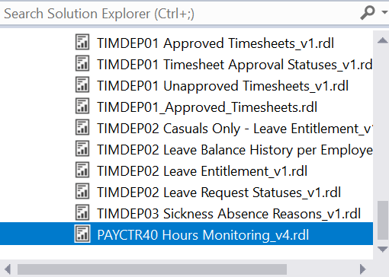

Opening a report (.RDL)
To open an .RDL, scroll to it in the Solution Explorer pane and either double-click it, or right-click and select Open from the menu:

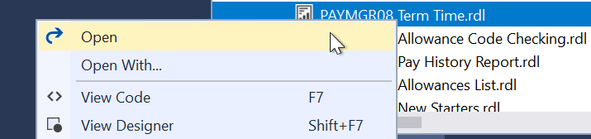

The .RDL file will load and the report’s Design pane will be displayed.

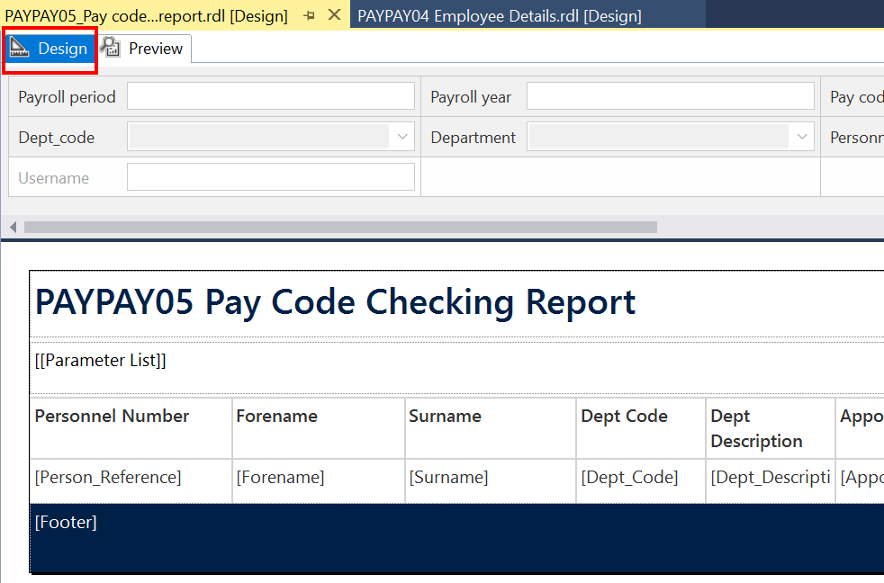

The Design pane
All .RDL files within Visual Studio have a Design pane, where you can format the data from your SQL query into a user-friendly report. The Design pane for every report in the HR Reporting catalogue must contain the following elements:

Parameter fields
If your report has parameters, these must appear above the report as interactive fields (free-text, drop-down, or date/time).

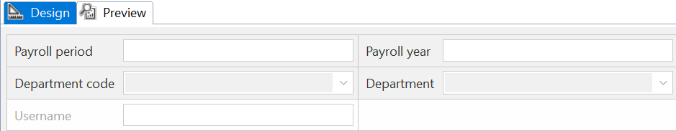

 | NB: If your report does not have interactive parameter fields, users will not be prompted to enter parameters when they run the report.

Title textbox
This textbox appears at the top of the report and contains the title of the .RDL file, in the format [Report prefix] + [.RDL name], e.g. PERDEP01 Limited Data Set.

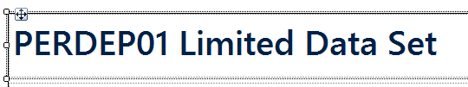

Parameters textbox
This textbox appears underneath the Title, and contains a VBA expression which will display the parameters a user has selected each time the report is run. In the Design pane, it looks like this:

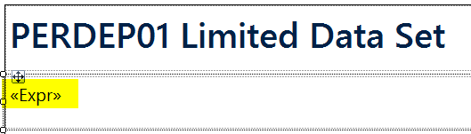

When a report has been run, the Parameters textbox looks like this:

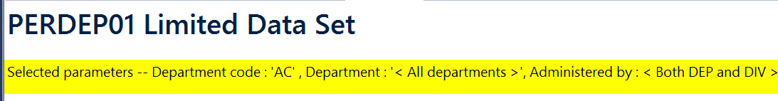

Report Tablix
The “Tablix” (a Microsoft term) displays report data from a data set in cells that are organized into rows and columns. This is where your report fields are arranged and formatted, and where your results appear when you run the report query. A Tablix can be formatted as a simple table or as a matrix.

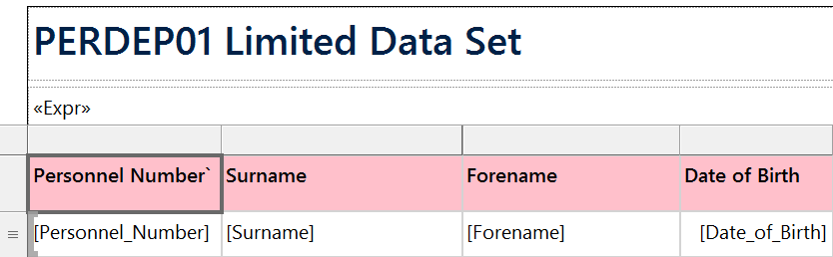

Footer textbox
This textbox appears at the bottom of the screen, and contains a standard VBA expression which will display a message whenever the report is run. The message states the name of the .RDL file, the SSO of the username who ran the report, as well as the date and time of the report run. In the Design pane, it looks like this:

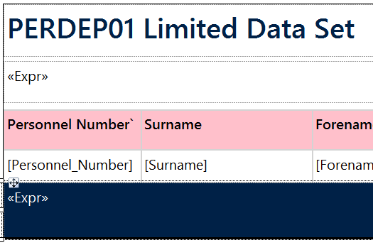

When a report has been run, the Footer textbox looks like this:

The Preview pane
All .RDL files within Visual Studio also have a Preview pane, where you can run your report query and check your results and your formatting without needing to deploy the report to the HR Reporting environments.

To open the Preview pane, simply click the tab at the top of the .RDL file. If your report has parameters, you will be prompted to fill them in, exactly as a report user would be on the HR Reporting environments:

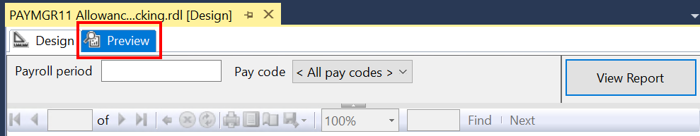

Enter the parameters you wish to use (or none if you don’t want to restrict your results), and click View Report to run the report query. The SQL code of your report will query the PeopleXD database to which your solution is connected, and the “Loading…” message will display while the query runs:

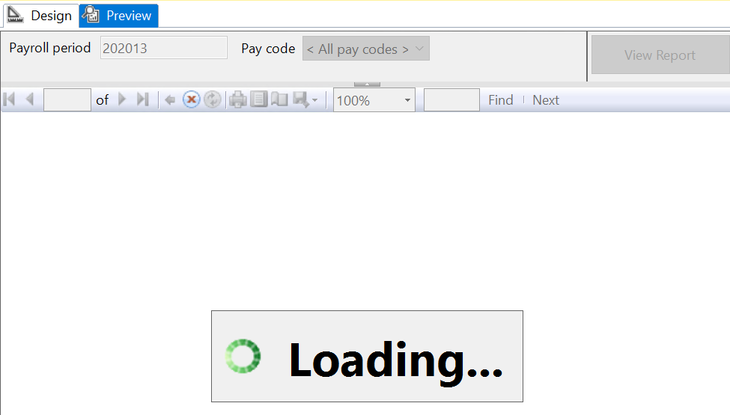

When the query is complete, the report results will load in the Preview pane. The page numbers at the top of the report indicate how many pages of results have been retrieved.

 | NB: The parameter prompts at the top of the screen can be edited if you want to re-run the report with new parameters – simply change the parameter values and click View Report to re-run your query.

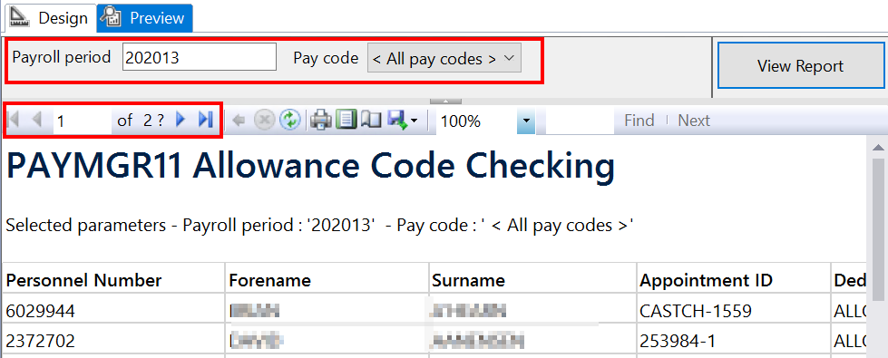

You can export your results by clicking the Save icon and choosing the export file format:

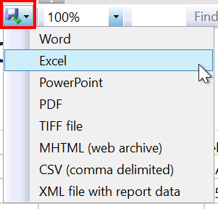
To exit the Preview pane, simply click back into the Design tab at the top of the .RDL file.

 | NB: Do not click back into the Design pane while the Preview pane is in “Loading…” mode – doing so often causes Visual Studio to freeze up and become non-responsive.

The Report Data pane
The Report Data pane is where you configure the individual elements of your .RDL file: its data sources, datasets, and parameters. The Report Data pane is located on the left side of the screen:

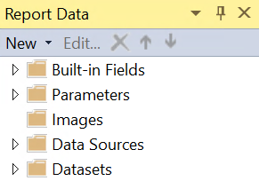

Expand any of the folders to view their contents. A brief description of each is given below.

 | NB: The Built-in Fields are essential components of all .RDL files, and are included as standard in every report. We don’t ever edit these values. We also don’t use the Images functionality within Visual Studio, so this folder can be ignored.

Parameters
The Parameters folder lists each parameter present in your report.

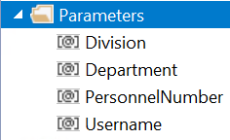

You can click into each parameter to view or edit its properties. Double-clicking a parameter will open the Report Parameter Properties window for that specific parameter, where you can view the parameter name, prompt text, data type, available values, and default values (if these have been set).

Data Sources
The Data Sources folder lists each data source present in your report. All reports must contain the two standard shared data sources:

- Oracle_DS_ServiceAccount: the service account is used to run the queries for shared datasets, e.g. to retrieve all department codes for use in a parameter’s drop-down list.
- Oracle_DS_UserCredentials: the user account is used to run the main report SQL code – it’s each report user’s individual reporting login credentials. By passing these credentials to PeopleXD, the database can automatically detect and apply the correct security when retrieving report results; e.g. a user who is only allowed to see Pay Group 20 will only see results for Pay Group 20.

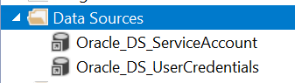

If you are missing either data source (for instance, if you are creating a new report), simply right-click the Data Sources folder and select Add Data Source….

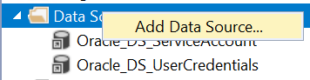

Datasets
The Datasets folder lists each dataset present in your .RDL file. This includes the main report query, as well as any additional datasets which are used to power your parameters.

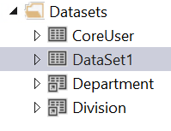

 | NB: The main report query should always be named “DataSet1”, while any parameter-related datasets should have descriptive names linking them to their parameters, e.g. Department for a dataset which provides a list of departments for the Department parameter.

Double-click any dataset to open the Dataset Properties window.

If you are looking at an embedded dataset, you can view the raw SQL code of the dataset in the Query pane:

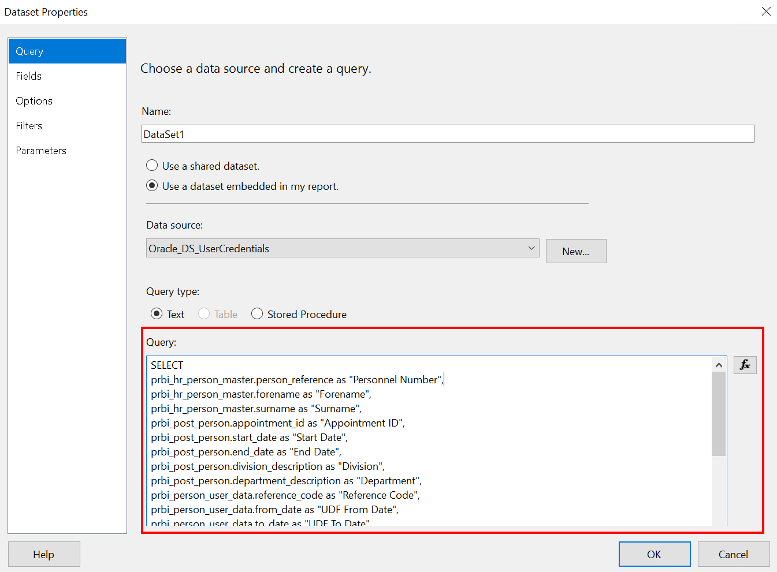

If you are looking at a shared dataset, you will be able to see the full name of the shared dataset – this will enable you to select the shared dataset from the Solution Explorer pane to view the SQL code for that dataset.

